***Virginia Junior Classical League***

*presents this*

Certificate of Excellence

*to*

Matthew Mott

*of*

Deep Creek High School

*for*

*2nd Place in Costume - Boys Upper Division*

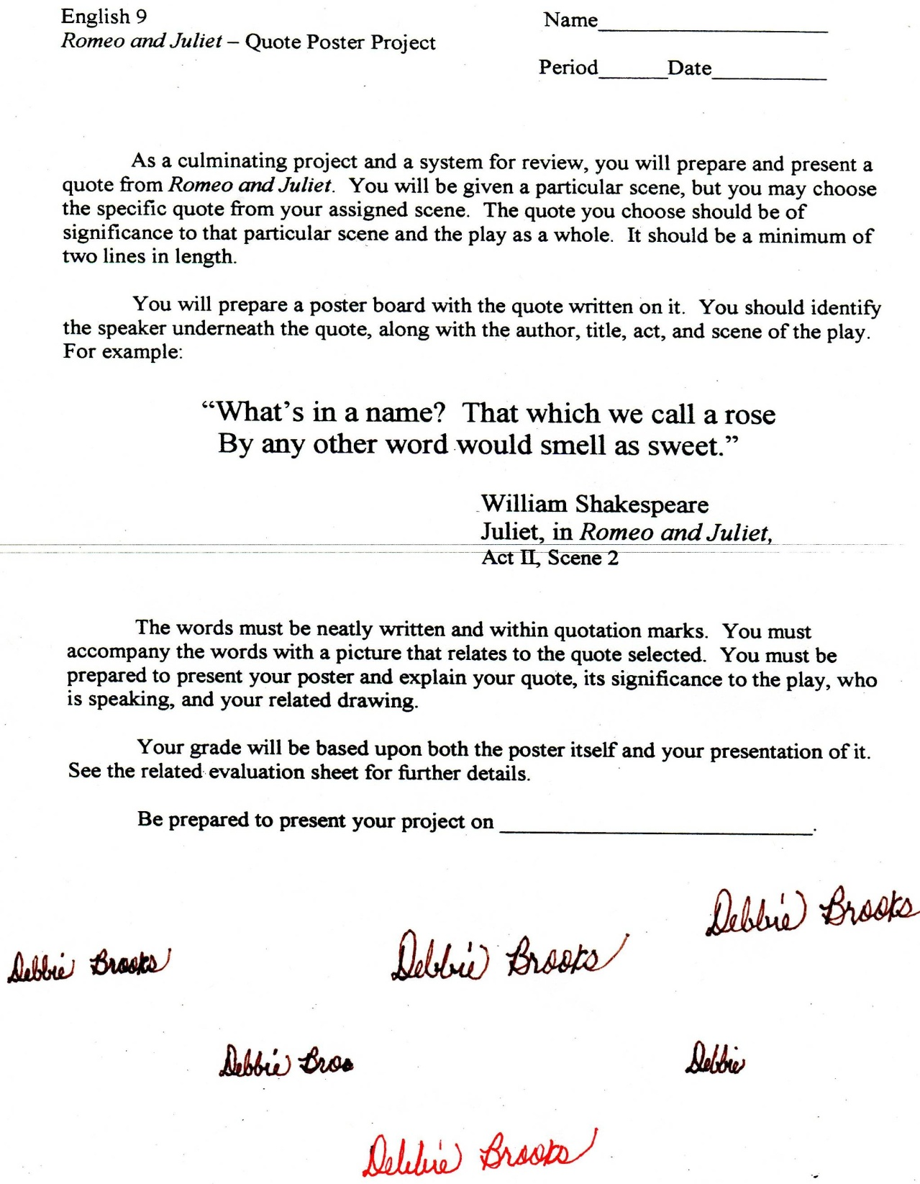

Microsoft Office Signature Line...

*a.d. viii Kal. Dec. MMDCCLXVII A.U.C. 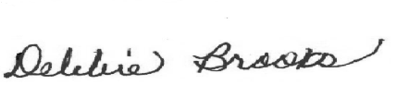*

***Virginia Junior Classical League***

*presents this*

Certificate of Excellence

*to*

Matthew Richardson

*of*

Deep Creek High School

*for*

*2nd Place in Geography*

**

Microsoft Office Signature Line...

*a.d. viii Kal. Dec. MMDCCLXVII A.U.C. *

***Virginia Junior Classical League***

*presents this*

Certificate of Excellence

*to*

Ebony Price

*of*

Deep Creek High School

*for*

*2nd Place in Photography*

**

Microsoft Office Signature Line...

*a.d. viii Kal. Dec. MMDCCLXVII A.U.C. *

***Virginia Junior Classical League***

*presents this*

Certificate of Excellence

*to*

Matthew Richardson

*of*

Deep Creek High School

*for*

*3rd Place in Sight Latin*

**

Microsoft Office Signature Line...

*a.d. viii Kal. Dec. MMDCCLXVII A.U.C. *

***Virginia Junior Classical League***

*presents this*

Certificate of Excellence

*to*

Matthew Richardson

*of*

Deep Creek High School

*for*

*5th Place in Grammar*

**

Microsoft Office Signature Line...

*a.d. viii Kal. Dec. MMDCCLXVII A.U.C. *

***Virginia Junior Classical League***

*presents this*

Certificate of Excellence

*to*

Gabby Turdici

*of*

Deep Creek High School

*for*

*5th Place in Life*

**

Microsoft Office Signature Line...

*a.d. viii Kal. Dec. MMDCCLXVII A.U.C. *

***Virginia Junior Classical League***

*presents this*

Certificate of Excellence

*to*

Ebony Price

*of*

Deep Creek High School

*for*

*6th Place in Other*

**

Microsoft Office Signature Line...

*a.d. viii Kal. Dec. MMDCCLXVII A.U.C. *

***Virginia Junior Classical League***

*presents this*

Certificate of Excellence

*to*

Matthew Richardson

*of*

Deep Creek High School

*for*

*6th Place in*

**

Microsoft Office Signature Line...

*a.d. viii Kal. Dec. MMDCCLXVII A.U.C. *

***Virginia Junior Classical League***

*presents this*

Certificate of Excellence

*to*

Michael Nguyen

*of*

Deep Creek High School

*for*

*7th Place in Cosume - Couples Upper Division*

**

Microsoft Office Signature Line...

*a.d. viii Kal. Dec. MMDCCLXVII A.U.C. *

***Virginia Junior Classical League***

*presents this*

Certificate of Excellence

*to*

Maria Curiel

*of*

Deep Creek High School

*for*

*7th Place in Cosume - Couples Upper Division*

**

Microsoft Office Signature Line...

*a.d. viii Kal. Dec. MMDCCLXVII A.U.C. *

***Virginia Junior Classical League***

*presents this*

Certificate of Excellence

*to*

Liz Wooten

*of*

Deep Creek High School

*for*

*7th Place in Life*

**

Microsoft Office Signature Line...

*a.d. viii Kal. Dec. MMDCCLXVII A.U.C. *